Summary
This article describes how to prepare and import student/staff photos into PowerSchool.
To import photos into PowerSchool you will need 4 things:

- You will need a flat ZIP file containing all the Student photos you wish to import.
- You will need a tab-delimited text file that maps Student_Number to the exact filename of their Student photo.
- You will need a flat ZIP file containing all the Staff photos you wish to import.
- You will need a tab-delimited text file that maps TeacherNumber to the exact filename of their Staff photo. This file cannot be zipped.

Preparing the Mapping File
PowerSchool needs you to tell it which photo belongs to which Student / Staff member. To do this, you must make a Mapping file that you will import at the same time as the photos.

Typically, you will construct your mapping file using a spreadsheet application such as Microsoft Excel. Whatever program you use, make sure you save the file as Tab-Delimited Text. This is the only format PowerSchool recognizes. Note, this file cannot be in a zipped format.

If the pictures were prepared by a third party vendor, the third party may be able to provide you with the map file based on the current specifications. Please contact your vendor for additional information.

Example
A student has a Student_Number of 12345, and their corresponding picture is 67890.jpeg; the first line in your import map file will look similar to the following:
12345 67890.jpeg

The Student_Number value is in the first column, and the name of the image file is in the second column.

Important Note
Your imports may not work if the following required items are not addressed as follows:
- There must be a separate mapping file for Students and a separate mapping file for Staff.
- If the filename of the photo contains leading zeros (Example: 001.jpg), your mapping file must also contain leading zeros.
- If the filename of the photo uses the .jpeg extension, your mapping file must also use the .jpeg extension. By the same token, if the filename of the photos uses the .jpg extension, your mapping file must also use the .jpg extension. The mapping file is case-sensitive.
- Windows and macOS may not show the file extensions by default. Right clicking the file and selecting Properties (Windows) or Get Info (macOS) can be used to view the actual file extension. This is case-sensitive in the mapping file.
- You may have additional columns in your mapping file while you're constructing it, but you should save the final version with only two columns.

Preparing the Pictures/ZIP File
So that you can import the photos all at once instead of individually, they will need to be packages in a ZIP archive file.

If the pictures were prepared by a third-party vendor, make sure they are provided to you in a JPEG format and are named after the student's Student_Number if at all possible. This will make your life easier.
- (Required) Image files must be in the JPEG/JFIF format with a file extension of .jpg or .jpeg.
- (Recommended) It is recommended that the image file's aspect ratio be 200 pixels wide by 300 pixels high. If your photos appear stretched or distorted after import, you may need to ensure the display dimensions of the photos match the image sizes by taking the following steps: from the Start Page, select District Management, then District Setup then Additional System Preferences, then Dimensions.
- (Required) The photos must be in a ZIP file. Other compression types such as .SIT, .RAR, and .7z are not accepted.
- (Required) The Student Photos should be in their own ZIP file. They will be uploaded separately from Staff Photos.
- (Required) The Staff Photos should be in their own ZIP file. They will be uploaded separately from Student Photos.
- (Required) The ZIP file must be flat. When compressing the photos, highlight all the photo (*.jpg) files, and compress that selection, rather than compressing a folder containing these photos. The compressed zip file should not contain any sub-folders.
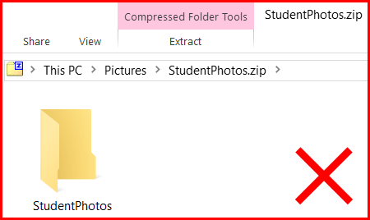Screenshot of a file window on a computer illustrating the incorrect way to format a file for upload.
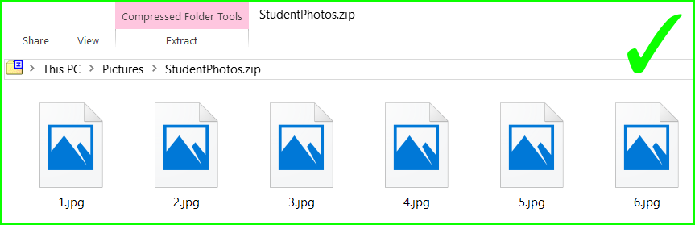Screenshot of a file window on a computer illustrating the correct way to format a series of files f...
- (Required) The Import Mapping file cannot be in the ZIP file(s). It must be it's own separate file that is not zipped up.

