Under the Admin tab, click on Users.
Click on Advanced User Options.
Click in the box under Add Group Role.
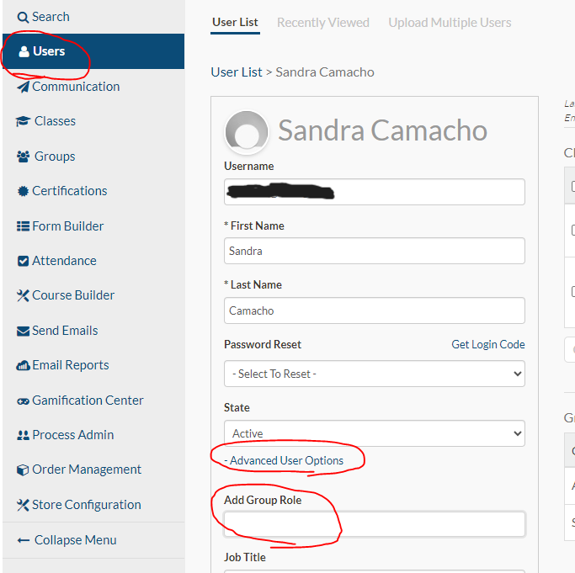
On the drop-down menu, click on User Admin. Then click OK.
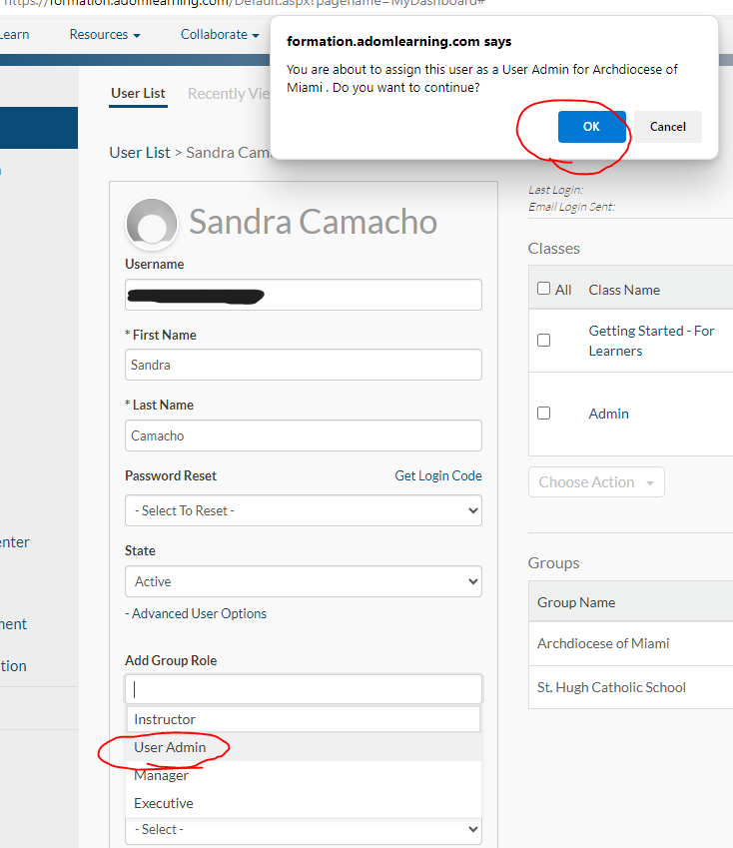
Then scroll to the bottom and click Submit.

